1

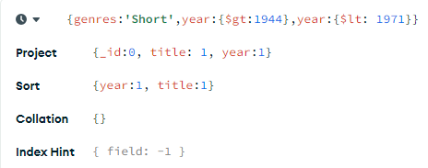

2

use sample_mflix



3

use sample_mflix

db.movies.find(

{$group:rated, year:{$gt:1950})

4

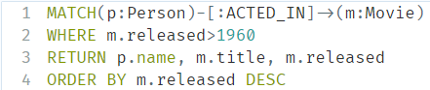

5

